Holsen — Before vs After MAIA Workflow
Format follows Macrofood/macrofrozen/27Jul26 - Macrofrozen E2E Flow and Per-Role Breakdown and Dalson — Before vs After MAIA and E2E Flow. Sourced from Client Overview, Config Overlay, Onboarding Status, Holsen MAIA User Guide - Mr Tam Team, Holsen — PM Handover Brief, and the Holsen - Customer Onboarding Checklist (Lark) for named users/roles and permission matrix.
Corrected 2026-08-03: the earlier draft claimed "no named client contact anywhere in the KB" — that's now resolved. The Customer Onboarding Checklist's Roles Definition table (§A8) names every user and role. Per-role section below now uses real names and titles instead of functional placeholders. It also corrected a wrong delivery assumption — Holsen has no own fleet; all deliveries go through third-party transporters (Menaka for local, GMax and Tiong Nam Logistics for outstation).

Before MAIA — Current (As-Is) Flow
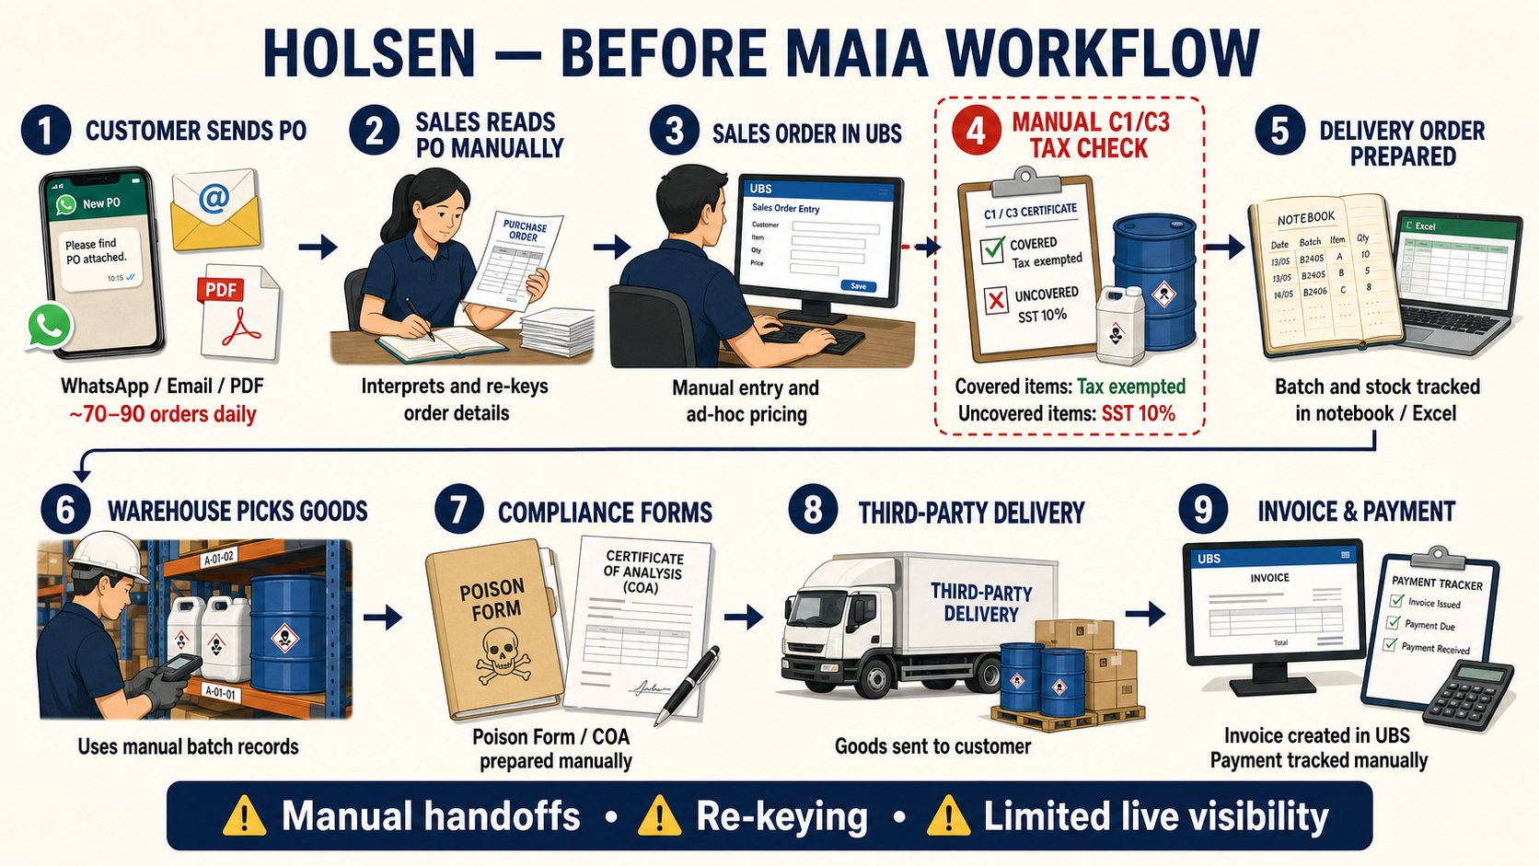

┌───────────────────────────┐
│ Customer sends PO │
│ WhatsApp / email / PDF │
│ (manual, ~70–90/day) │
└─────────────┬─────────────┘
▼
┌───────────────────────────┐
│ Sales staff reads PO, │
│ interprets manually │
└─────────────┬─────────────┘
▼
┌───────────────────────────┐
│ Sales Order keyed into │
│ UBS manually │
│ • Price negotiated ad hoc │
│ • No structured approval │
│ • C1/C3 checked manually │
│ • Covered: tax exempted │
│ • Uncovered: SST 10% │
└─────────────┬─────────────┘
▼
┌───────────────────────────┐
│ Delivery Order prepared │
│ manually │
│ • Batch/stock tracked in │
│ notebook/Excel │
└─────────────┬─────────────┘
▼
┌───────────────────────────┐
│ Warehouse picks by batch │
│ from notebook records │
│ • Poison/hazardous items │
│ need physical form │
└─────────────┬─────────────┘
▼
┌───────────────────────────┐
│ Goods delivered │
│ (own fleet / outstation │
│ transporter e.g. Tiong Nam)│
└─────────────┬─────────────┘
▼
┌───────────────────────────┐
│ Invoice created in UBS │
└─────────────┬─────────────┘
▼
┌───────────────────────────┐
│ Payment tracked manually │
└────────────────────────────┘
- Customer sends a PO — WhatsApp, email, or PDF — directly to Holsen sales staff. High volume: ~70–90 customer POs a day.
- Sales staff reads and interprets each PO manually, then keys it into UBS as a Sales Order.
- Pricing is negotiated ad hoc — commodity items in particular need manual price confirmation each time, no system-enforced minimum price check.
- No structured approval workflow — credit limit and payment terms are checked manually by whoever is handling the order.
- Manual C1/C3 tax-exemption check: During Sales Order entry, staff checks the ordered items against the customer's valid C1/C3 certificate. Items covered by the certificate are tax exempted; items not covered are charged SST 10% by default.
- Batch and stock tracking lives in notebooks/Excel, not a live system — matches the "current tools being replaced" listed in Client Overview.
- Poison/hazardous chemical items require a physical government-mandated form before the driver can leave with the goods — tracked manually today.
- Delivery is via Holsen's own fleet or an outstation transporter (e.g. Tiong Nam) for out-of-area drops.
- Invoice generated in UBS, with tax handling performed manually: items covered by the customer's valid C1/C3 certificate are tax exempted, while uncovered items are charged SST 10% by default.
- Payment tracked manually — no automated receipt/knock-off flow.

Problems this creates
- High manual PO volume (~70–90/day) with no structured intake — every order depends on staff correctly reading and re-keying WhatsApp/email/PDF messages into UBS.
- Pricing consistency depends on memory — no system record of last price charged to a customer, especially for commodity items needing manual confirmation each time.
- No enforced credit/approval gate before delivery — credit limit and payment-term checks are manual, so an over-limit order can slip through before anyone catches it.
- Batch/stock tracking in notebook or Excel — no live visibility of what's actually in which warehouse, no FEFO enforcement, no traceability from batch to invoice.
- Compliance paperwork and C1/C3 tax checks are handled manually per order. Staff must compare ordered items against the customer's certificate; covered items are tax exempted and uncovered items are charged SST 10% by default.
- UBS is the system of record with no direct integration — Holsen's own tools (WhatsApp, UBS, notebooks) don't talk to each other; everything is re-entered by hand at each handoff.

After MAIA — E2E Flow: Order Intake → Payment
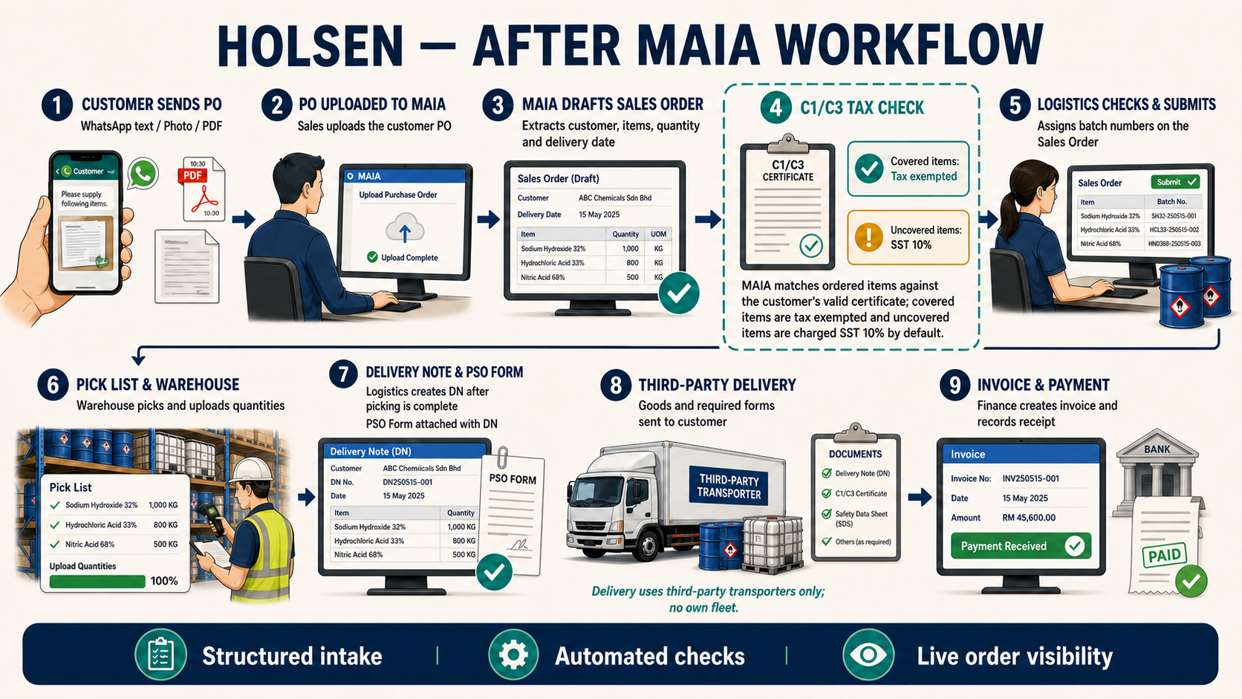
CUSTOMER
|
| Sends PO (WhatsApp text, photo, or PDF) — Telegram @maia_holsen_bot for UAT,
| WhatsApp Sales Agent chatbot at go-live
v
SALESMAN
|
| Uploads the customer PO into MAIA
v
MAIA
|
| Extracts customer, items, quantities, delivery date from the PO
| Drafts the Sales Order
v
SALESMAN
|
| Creates / reviews the Sales Order from the extracted PO
| Checks customer C1/C3 certificate against ordered items
| Covered items: tax exempted
| Uncovered items: SST 10% charged by default
v
LOGISTICS
|
| Checks the Sales Order
| Submits the Sales Order
| Adds batch number for each item to be picked (on the SO itself)
v
Converts the Sales Order into a Pick List
v
Pick List generated → sent to Warehouse
|
v
WAREHOUSE
|
| Picks the item quantities per the Pick List
| Uploads the picked quantities back into MAIA
v
Pick List marked Complete
|
v
LOGISTICS
|
| Creates the Delivery Note (DN) once the Pick List is complete
| Attaches the PSO Form with the DN
v
FINANCE
|
| Creates the Invoice
| Tax applied by SKU tag: Manufacturing = SST 10% default, Trading = 0% default
| Payment due date = invoice date + 30 days (Net 30)
v
Invoice sent to customer (email/WhatsApp)
|
v
FINANCE
|
| Records payment on receipt, creates Receipt in MAIA
v
SALES ORDER LIFECYCLE COMPLETE

Corrected 2026-08-03 (per direct client instruction): the flow below replaces an earlier draft that assumed a separate Finance-approval gate before the Delivery Note, and batch selection happening at DN stage. Actual flow: Logistics — not Finance — checks and submits the Sales Order, batch numbers are assigned on the SO itself (before it becomes a Pick List), and there's no confirmed Finance-approval checkpoint between SO and DN. Open question: the Config Overlay and User Guide both describe a Finance-approval-before-DO step and manual credit/limit checks — unclear whether that still happens somewhere in this flow (e.g. folded into Logistics' SO check) or was dropped in practice. Flag for verification.

1. Order Intake
- Customer sends their PO to the MAIA Sales Agent chatbot — WhatsApp text, a photo of the PO, or a PDF. UAT channel is Telegram (@maia_holsen_bot); go-live channel is WhatsApp (pending Meta account setup — see PM Handover Brief gotcha on this cutover being unclear as of June).
- Salesman uploads the PO into MAIA; MAIA extracts customer name, items, quantities, and delivery date.
- Customer and items must already exist in MAIA — if either is missing, the Salesman escalates to the MAIA admin rather than MAIA creating them inline (unlike Dalson/Macrofrozen's chatbot-driven new-customer creation — not confirmed as a Holsen feature, treat as a gap to verify).

2. Sales Order Creation
- Salesman creates/reviews the Sales Order drafted from the extracted PO — corrects any extraction errors (especially likely on handwritten or unclear POs) and confirms the selling price.
- Duplicate check: same customer + PO number → MAIA blocks creation as a duplicate; must verify before proceeding.
- Minimum price check: MAIA warns if the entered price is below the item's minimum.
- C1/C3 tax-exemption check: During Sales Order creation, MAIA checks the ordered items against the customer's valid C1/C3 certificate. Items covered by the certificate are tax exempted; items not covered are charged SST 10% by default.
- Pricing by SKU tag (corrected 2026-08-03, source: 2026-05-22 "Holsen C1/C3 Testing" Granola transcript, client-facing):
- Trading items default to price = RM0 — by design, not a bug (also flagged in PM Handover Brief Gotchas). Salesman must manually key in the price on every Trading-item order, unless the customer already has a customer-specific price set — MAIA checks for existing customer pricing first, and only falls back to the RM0 default / manual entry if none exists.
- Commodity items still require manual price confirmation each time regardless of customer pricing (Config Overlay: "Commodity manual confirmation").

3. Logistics Check, Submit & Batch Assignment
- Logistics checks the Sales Order and submits it — this is the actual submission gate, not Sales and not (confirmed) Finance.
- Logistics adds the batch number for each item to be picked, directly on the Sales Order — batch assignment happens before the SO becomes a Pick List, not later at DN stage.
- SKU classification tags drive downstream behaviour: Trading (standard pick-and-pack, price defaults to RM0, 0% SST default), Manufacturing (Logistics must check with Production first, SST 10% default), Poison/Hazardous (triggers a "POISON FORM REQUIRED" alert), Commodity (Sales price-confirmation prompt), COA Required (Certificate of Analysis auto-attached).
- C1/C3 tax treatment is determined during Sales Order creation by matching the ordered items against the customer's certificate: covered items are tax exempted, while uncovered items are charged SST 10% by default. Logistics verifies the resulting order before submission.

4. Sales Order → Pick List
- Logistics converts the submitted, batch-assigned Sales Order into a Pick List.
- The Pick List is generated and sent to the Warehouse team.

5. Picking (Warehouse)
- Warehouse picks the item quantities per the Pick List — item, quantity, batch number.
- Warehouse uploads the picked quantities back into MAIA.
- Pick List is marked Complete once all quantities are uploaded.

6. Delivery Note (Logistics)
- Once the Pick List is complete, Logistics creates the Delivery Note.
- Partial delivery is supported — a Delivery Note can be created for less than the full ordered quantity, with the Sales Order tracking overall fulfilment until the remainder is delivered on a later DN. Unconfirmed whether this still holds under the corrected flow — carried over from the earlier draft, needs re-verification.
- Poison/hazardous items trigger the "PSO FORM REQUIRED" alert at this stage. Logistics prepares the PSO Form and attaches it with the Delivery Note before delivery.

7. Delivery
- The third-party transporter takes the goods and Delivery Note, with the PSO Form attached to the DN when required.
- Third-party transporter — Menaka (local) or GMax/Tiong Nam Logistics (outstation), depending on delivery-type classification (Local vs. Outstation, auto-classified from postcode). No own fleet — corrected 2026-08-03.

8. Invoice (Finance)
- Finance creates the Invoice — from the Delivery Note.
- Tax applied by SKU classification tag, not a flat split (corrected 2026-08-03, source: 2026-05-22 "Holsen C1/C3 Testing" Granola transcript):
- Manufacturing-tagged items → SST 10% by default ("in manufacturing, automatically 10% to manufacturing tag"; "manufacturing... SSD 10%. That's it. ... 10%, as a default.").
- Trading-tagged items → 0% by default ("Trading. 0%. Trading tax values in trader.").
- This is the item's own tax default, separate from A57 tax exemption enforcement, which is deferred to post-go-live (per Client Overview / Config Overlay), and separate from C1/C3 certificate-based exemptions (see Compliance Documents below).
- Payment due date defaults to invoice creation date + 30 days (Net 30).
- Invoice sent to the customer via email or WhatsApp.

9. Payment & Receipt (Finance)
- On payment, Finance creates a Receipt against the Invoice with amount and date.
- Sales Order lifecycle is complete.

10. Compliance Documents (C1/C3) — SO-level live-tested, DN/Invoice-level still open
- C1 (perpetual manufacturer tax-exemption certificate) and C3 (per-order import-on-behalf exemption) are used during Sales Order creation to determine tax treatment. Ordered items covered by the customer's valid certificate are tax exempted; items not covered are charged SST 10% by default.
- Corrected 2026-08-03 (checked directly against Granola transcripts, not just the handover doc): dedicated client UAT sessions on 15 and 22 May 2026 confirmed working live — C1/C3 certificate creation, PDF upload, applying a certificate to a Sales Order, and matching ordered items against certificate coverage. Covered items are tax exempted; uncovered items are charged SST 10% by default.
- Still open: DN/Invoice-level C1/C3 behavior was never fully tested — the 15 May session stalled at Delivery Note creation because C3 line items need a batch/serial assignment first. Two live bugs also surfaced (PDF-uploaded certs not showing tax reference on the finance side; stock-notification not firing) with no confirmed fix on record. The UAT form itself (Tests 24–36) still has no Pass/Fail box ticked — a sign-off/paperwork gap, not evidence the feature wasn't tested.
- See Holsen — PM Handover Brief C1/C3 Deep Dive for full detail and direct transcript quotes.

Per-Role: What Each User Does
Corrected 2026-08-03: named users and roles now sourced directly from the Holsen - Customer Onboarding Checklist (Lark), §A8 Roles Definition + Role Permissions Configuration. Permission-matrix columns are SALES MANAGER / LOGISTICS MANAGER (Logistics) / LOGISTICS MANAGER (Procurement) / LOGISTICS MANAGER (Production) / FINANCE MANAGER / Admin / System Admin — cited inline below where relevant.

Sales — Tam Ze Xin (Sales, Admin/Operations — primary contact) & Ng Tze Chien (Sales Manager)

Responsibilities
- Receives the customer PO, uploads it into MAIA via the Sales chatbot.
- Creates/reviews the MAIA-extracted Sales Order, corrects errors, confirms the selling price — manually keys in price for Trading items (default RM0) unless a customer-specific price already exists; manual confirmation always required for Commodity items.
- Does not submit the SO — Logistics checks and submits it (corrected 2026-08-03; earlier draft had this role submitting to a Finance-approval gate). Matches the permission matrix: Sales Manager has Sales Order = READ only, full CRUD+SUBMIT on Quotation and Purchase Order only.

Benefits
- No longer manually re-keying every PO into UBS from scratch — MAIA drafts the order first.
- Duplicate-PO and minimum-price checks catch two of the most common manual-entry errors before submission.

Risks
- Extraction errors on handwritten or unclear POs still require careful manual review — not eliminated, just surfaced earlier.
- New customer/item setup still routes to the MAIA admin rather than being self-service — unconfirmed whether this is intended as permanent or a current gap.

Finance — Wong Shui Fern (Finance User / Finance Manager)

Responsibilities
- Creates the Invoice once the Delivery Note exists; applies tax per item. Submits Payment. Per the permission matrix, Finance actually has full CRUD+SUBMIT on Sales Order too — she is not locked out of the SO, even though the day-to-day E2E flow routes SO submission through Logistics.
- Records payment and creates the Receipt.

Benefits
- Payment due date is calculated automatically (invoice date + 30 days) instead of tracked manually.

Risks
- No confirmed approval/credit-check step before the DN in the corrected flow — the Config Overlay and User Guide both describe Finance reviewing order accuracy and checking credit limit/payment terms before a Delivery Note is created (manual in A1, automated in A2). That gate doesn't appear in the client-confirmed flow above, where Logistics checks and submits the SO directly — even though Finance's permissions would allow her to do it. Open question: is the credit/accuracy check actually happening (just informally, by whoever has access) or was it dropped? Needs direct client clarification.
- A57 tax exemption enforcement is not live at go-live — Finance must still manually verify tax classification is correct per the User Guide's troubleshooting table.

Logistics — Noor Aili Nafiah (Logistics Manager, Logistics)

Responsibilities
- Checks the Sales Order and submits it — the actual gate between Sales Order creation and fulfilment. Confirmed by the permission matrix: Sales Order = full READ/WRITE/CREATE/DELETE/SUBMIT, the only role with unrestricted SO control besides Finance and System Admin.
- Adds the batch number for each item to be picked, directly on the Sales Order (before it becomes a Pick List) — covered under her Inventory permission (Item, Batch, Serial No., Warehouse, Pick List, stock recon, stock entry — full CRUD+SUBMIT).
- Converts the submitted, batch-assigned Sales Order into a Pick List and sends it to Warehouse.
- Creates and submits the Delivery Note once Warehouse marks the Pick List Complete — matches her full CRUD+SUBMIT on Delivery Note.
- Handles SKU-classification-driven actions: preparing and attaching the PSO Form with the Delivery Note, Manufacturing hold for Production check, and COA auto-attach.
- Checks C1/C3 certificate eligibility at the Sales Order stage: items covered by the certificate are tax exempted, while uncovered items are charged SST 10% by default — see Compliance Documents below.

Benefits
- Batch assignment now happens once, on the SO, in MAIA — not re-keyed later at DN stage or tracked in a notebook.
- Poison/hazardous compliance is a system-triggered alert instead of something staff have to remember per order.
- Logistics has one clear checkpoint (SO check + submit) instead of the order silently passing through an unconfirmed approval step.

Risks
- This role now carries what used to look like split Sales-submission and Finance-approval responsibility — the permission matrix confirms she genuinely holds the widest operational write access of any non-admin role.
- Batch-not-showing and insufficient-stock errors still require warehouse/admin troubleshooting per the User Guide's common-issues table — not yet fully self-service.

Logistics (Procurement) — Intan Atikah

Responsibilities
- Read access to Quotation, PO, Invoice, Payment; SO and DN limited to READ + SUBMIT — can submit but not create/edit either document.
- Exact day-to-day duties not documented beyond the permission matrix — gap to verify (title suggests procurement/purchasing coordination, not floor logistics).

Production — Murugesu A/L Palanivello (Logistics Manager, Production)

Responsibilities
- Listed in the Roles Definition table with a "Production" role, but the permission matrix shows no populated access rows for this column — either a data-entry gap in the source sheet or this role genuinely has minimal/no MAIA access. Gap to verify — the Before-MAIA notes elsewhere in the KB flag Manufacturing-tagged SKUs needing a "check with Production" step; unclear if that happens inside MAIA or entirely outside it via this person.

Warehouse (floor staff — no named individual or MAIA role identified)

Responsibilities
- Receives the Pick List (generated by Logistics).
- Picks the item quantities per the Pick List — item, quantity, batch number.
- Uploads the picked quantities back into MAIA; Pick List is marked Complete once done.

Gap
- No warehouse-floor role or named person appears in the Roles Definition table — the Inventory/Pick List permission (full CRUD+SUBMIT) sits with Noor Aili Nafiah (Logistics Manager), not a separate warehouse user. Either floor staff work under her account, or there's an unnamed/undocumented warehouse login. Needs direct verification — this is the same kind of gap Dalson had with Joseph before that got resolved by name.

Admin — Ong Siow Chui (System Admin) & Tam Ze Xin / Chin Zhao Heng (System Admin, full access)

Responsibilities
- Ong Siow Chui: all-roles Admin access — Quotation/PO/read, SO/Invoice/Payment CRUD (no submit noted), Inventory/DN read, Issue CRUD.
- Tam Ze Xin and Chin Zhao Heng (Boss): System Admin — full access to everything, per the matrix's explicit "Have access to everything" note.

Delivery — Third-Party Transporters (Menaka, GMax, Tiong Nam Logistics) — corrected 2026-08-03, no own fleet

Responsibilities
- Holsen has no own delivery fleet. All deliveries go through third-party transporters: Menaka (local), GMax and Tiong Nam Logistics (outstation).
- Delivers goods per the Delivery Note; the PSO Form is attached with the DN for hazardous items when required.
- There is no system-driven delivery-option selection in MAIA (no standard/express, no COD, no self-collect) — delivery confirmation happens only two ways: the customer confirms goods received, or the transporter's Delivery Order (DO) is returned, local or outstation.

Not a MAIA user
- Transporters are external — no confirmed MAIA login. Same pattern as Dalson's Lalamove.

Open Gaps Carried Into This Doc
- No named client contacts — resolved 2026-08-03: full Roles Definition table found in the Customer Onboarding Checklist (Lark) — see Per-Role section above for all 8 named users.
- New customer/item creation path — unclear whether this stays admin-only (current User Guide behaviour) or becomes chatbot-driven like Dalson/Macrofrozen. (open)
- Own-fleet driver's MAIA access — resolved 2026-08-03: there is no own fleet; all delivery is via third-party transporters (Menaka, GMax, Tiong Nam Logistics), none of them MAIA users.
- Meta/WhatsApp cutover from Telegram UAT bot — still unclear as of the last handover whether go-live actually moved off @maia_holsen_bot. (open — see PM Handover Brief)
- C1/C3 compliance — SO-level handling (certificate creation/upload, application to the Sales Order, item-coverage matching, tax exemption for covered items, and default SST 10% for uncovered items) is confirmed live-tested with the client (15/22 May 2026). Still open: DN/Invoice-level behavior (blocked on batch assignment, never re-tested), two live bugs (PDF tax-reference display, stock notification), and formal Pass/Fail sign-off on the UAT form. (open — see PM Handover Brief C1/C3 Deep Dive)
- Finance vs Logistics approval-gate discrepancy — Config Overlay/User Guide describe a Finance approval step before DN; the client-confirmed flow has Logistics checking and submitting the SO directly, though Finance's permissions still allow full SO access. Unclear if credit checking still happens somewhere in practice. (open)
- Warehouse floor-staff role — no named individual or distinct MAIA role found for warehouse picking; Inventory/Pick List permissions sit entirely with Noor Aili Nafiah (Logistics Manager). (open)
- Logistics (Production) role — Murugesu A/L Palanivello is named with a Production role, but the permission matrix shows no populated access for that column. (open)

See Also
- Holsen — PM Handover Brief
- Client Overview
- Config Overlay
- Onboarding Status
- Holsen MAIA User Guide - Mr Tam Team
- Holsen - Customer Onboarding Checklist (Lark, IShHwGOY9iNabKkn9iFlYDL9g7f) — named users, roles, permission matrix
- Dalson — Before vs After MAIA and E2E Flow
- Macrofood/macrofrozen/27Jul26 - Macrofrozen E2E Flow and Per-Role Breakdown

